Inter-branch Manager
(Transactions update between GIS Users)

This program has been developed for the system to update Inter-branch Transactions among GIS users that are already on SQL2008 and SQL2000.
The current users that will take advantage of this feature are BRAC of B.C. Ltd., BRAC of Victoria Ltd and Devon Transport Ltd.

The systems identify all the Inter-branch transactions such as:
  - Contracts that involved at least one vehicle for which
Pick up location is foreign
OR
Drop off location is foreign
  - Contracts that during the lifecycle of the contract have involved a foreign vehicle
There are 3 types of Inter-branch transactions:
One Way – Owing Company of the vehicle sending the vehicle to the location that belong to another owning company
Local Rental – Renting Company rent a vehicle belong to another owning company locally
Rent /Sent back - Renting Company rent a foreign vehicle back to the location that belongs to the vehicle owing company or to a location closer to the vehicle owning company
With this Version of Interbranch Manager, the renting city will be the soul of any transactions related data entry

Contract Checked Out
Sending
Receiving
Owning

When a contract is opened that has any relationship to a Inter-branch transaction, the GIS system will replicate/mirror the contract data over to the database of Owning Company of the vehicle and the database of the location where the vehicle is going to drop at.

- Renting City – the original copy of the rental agreement
- Owning City – a rental agreement (Rent Back contract) will be automatically generate by the system along with foreign contract number
- Receiving City – a FCO (Foreign Contract Open) will be automatically generated by the system for the Receiving City to close the contract.

With this Version of Interbranch Manager, the renting city will be the soul of any transactions related data entry

Changes during Rental

Sending
Receiving
Owning

Extension

Changing City:
- If this city does not belong to the same Owning Company
- Must contact to Renting city for authorization, if approved,
- Renting city will update the extension and obtain additional credit card authorization in GIS

Renting City will update to Owning Company
Renting city will update to Receiving City

- If this city belong to the same Owning Company or Receiving City
- Must contact to Renting city for authorization, if approved,
- Renting city will update the extension and obtain additional credit card authorization in GIS

Renting City will update to owning company
Renting city will update to receiving city

Obtain authorization is very critical as Renting City requires to obtain and/or process additional fund on customer's credit card.
Some of the vehicle may not allow for extension due to Km or Turn Back restriction and Renting City must be the one who approve for the extension.

Change drop off location

Changing City must contact the Renting city for authorization.
(Even the "Changing City" is part of Owning Company)
- Renting City will provide Drop Charges to Changing City
- Renting city will update the new drop off Location along with the new drop charge in GIS, and obtain additional credit card authorization in GIS

Renting City will update to Owning Company
Renting city will update to new Receiving City (if drop city belong to another Owning Company, the original CFO- Contract Foreign Open will be voided and a new CFO- Contract Foreign Open will be generated)

Obtain authorization is very critical as Renting City requires to obtain and/or process additional fund on customer's credit card.
And provide the new drop off charge to Changing City.

With this Version of Interbranch Manager, the renting city will be the soul of any transactions related data entry

Add or Remove Coverage/Optional Extra

Changing City:
Must inspect vehicle and contact Renting City prior to add or remove any items for the Original rental agreement

Coverage - LDW / PAI / PEC / ELI
The charges on the above coverage are based on the rate sold from the "Renting City"
Authorization must be obtained from the Renting City due to different policy between Owning Company

- Change City - if approved, manually add on the Rental Agreement of the effective date and time of the item/s and have the customer sign to accept the changes
- A copy of the changes is to be fax to DOP department of the Renting City

Renting city will update the changes in GIS and obtain additional credit card authorization in GIS and/or process additional fund on credit card. Once updated, the information will replicate over to the owning city and the receiving city.

Optional Extra - Baby Seat/ GPS/ SKI Rack
The charges on the above Optional Extra are based on the rate sold from the "Changing City"
- Manually add on the Rental Agreement of the item and have the customer sign to accept the changes.
- A copy of the changes is to be fax to DOP department of the Renting City
Renting city will update the changes in GIS and obtain additional credit card authorization in GIS and/or process additional fund on credit card. Once updated, the information will replicate over to the owning city and the receiving city.

Optional Extra - Out of Area charges
Must call to obtain authorization from Renting City
(Even the "Change City" is part of Owning Company)
Renting city will update the changes in GIS and obtain additional credit card authorization in GIS and/or process additional fund on credit card. Once updated, the information will replicate over to the owning city and the receiving city.

Additional Driver
Must call to obtain approval from Renting City
(Even the "Change City" is part of Owning Company) - due to minimum age requirement among owning company)
Renting city will update the changes in GIS and obtain additional credit card authorization in GIS and/or process additional fund on credit card. Once updated, the information (charge item) will replicate over to the owning city and the receiving city.

With this Version of Interbranch Manager, the renting city will be the soul of any transactions related data entry

Vehicle Problem

Vehicle breaks down due to Accident/ Vehicle mechanical problem
Must contact the Renting city for authorization and Purchase order before any vehicle replacement

If involve in an accident, the customer is required to fill out an "Accident Report"

Replacement (Contract exist in GIS)
- If approval for replacement vehicle - ( Vehicle belongs to the same Owning Company)
- User can make the vehicle replacement in the GIS system - follow the procedure of Vehicle Replacement

- If approval for replacement vehicle - (Vehicle belong to another Owning Company – GIS member)
- User can make the vehicle replacement in the GIS system - follow the procedure of Vehicle Replacement

Replacement (Non-GIS members)
- If approval for replacement vehicle - User will open a new contract in GIS system for replacement. The original contract number will need to be entering in Comment and copy of the open contract will fax over to Renting City and Owning Company of the vehicle. Renting city will update the replacement in GIS.

No Replacement:
Check in the vehicle with the actual date in, time in, KM in and the fuel charge.
The Inter-branch manager will replicated over to the database of the renting city and the owning city of the vehicle.

With this Version of Interbranch Manager, the renting city will be the soul of any transactions related data entry

Contract Checked In

Sending
Receiving
Owning

The Inter-branch Manager will automatically update the contracts to the Renting City and the Owning city upon contract checked in and updated in the system.

Contract Adjustment

Sending
Receiving
Owning

Any adjustments along with internal comment will be updated among the Renting City, Owning City and Receiving City within the database of the GIS system. The revenue split will be calculated according from the adjustment and the user can decide whether or not to import the adjustment to ACCPAC.

What trigger an Interbranch contract between GIS systems?
Any one of the Renting city, Owning city and Receiving city are not belong to the same Company.

A module under Contract will be created showing all contracts requires to obtain additional authorization, check in contract and process payment and/or process additional payment.

With this Version of Interbranch Manager, the renting city will be the soul of any transactions related data entry

Scenario 1) One Way
- Vancouver rent a BRAC vehicle one way to Nanaimo Airport with contract number 1434233
- This transaction meets the above criteria and an Inter-branch Manager created contracts between GIS systems. A rental agreement is created in Devon’s system by the inter-branch Manager as Contract #3032833 with Vancouver contract # 1434233 as foreign contract #
- When the customer dropped the vehicle at Nanaimo Airport on the due date, the user at Nanaimo Airport can retrieve the contract by
  - Foreign Contract #
  - Customer Last Name and First Name
  - Unit Number
  - Licence Plate Number
and update the rental agreement (3032833)
- Upon contract checked in, the Inter-branch manager will replicated over to Vancouver database between GIS system
- The DOP in Vancouver can pull out the original RA 1434233, review to ensure the charges are correct, collect Payment, check in the vehicle and update the rental agreement. A module under Contract will be created to show all contract need to be closed that was dropped at a foreign location

The Inter-branch Accounting will not have any entries unless the vehicle is not return full with fuel. If there is any fuel charge, the Vancouver Inter-branch Accounting will have a “Due to” entry to Devon for fuel and Devon Inter-branch Accounting will have a “Due From” entry from Vancouver for fuel.

Scenario 2) Rent/Sent Back
- Vancouver rent a Devon vehicle one way to Nanaimo Airport with contract number 1434218
- This transaction meets the above criteria and an Interbranch contract is created between GIS systems. A rental agreement is created in Devon’s system by the inter-branch manager as Contract #3032834 with Vancouver contract # 1434218 as foreign contract #
- When the customer dropped the vehicle at Nanaimo Airport on the due date, the user at Nanaimo Airport can retrieve the contract by
  - Foreign Contract #
  - Customer Last Name and First Name
  - Unit Number
  - Licence Plate Number
and update the rental agreement (3032834)
- Upon contract checked in, the Inter-branch manager will replicated over to Vancouver database between GIS system
- The DOP in Vancouver can pull out the original RA 1434218, review to ensure the charges are correct, collect Payment, check in the vehicle and update the rental agreement. A module under Contract will be created to show all contract need to be closed that was dropped at a foreign location

The Inter-branch Accounting will have entries between BRAC and Devon. Vancouver Inter-branch Accounting will have a “Due to” entry to Devon for revenue commission split based on One Way agreement and Devon Inter-branch Accounting will have a “Due From” entry to Vancouver for revenue.

Scenario 3) Rent/Sent Back
- Vancouver rent a Victoria vehicle one way to Nanaimo Airport with contract number 1434220
- This transaction meets the above criteria and an Interbranch contract is created between GIS systems. A rental agreement is created in Devon’s system by the inter-branch transaction manager as Contract #3032803 with Vancouver contract # 1434220 as foreign contract #. A rental agreement is created in Victoria’s system by the inter-branch manager as Contract #2935325 with contract # 1434220 as foreign contract #.
- When the customer dropped the vehicle at Nanaimo Airport on the due date, the user at Nanaimo Airport can retrieve the contract by
  - Foreign Contract #
  - Customer Last Name and First Name
  - Unit Number
  - Licence Plate Number
and update the rental agreement (3032803).
- Upon contract checked in, the information will be replicated over to Vancouver database and Victoria database.
- The DOP in Vancouver can pull out the original RA 1434220, review to ensure the charges are correct, collect Payment, check in the vehicle and update the rental agreement.

The Inter-branch Accounting will have entries between BRAC, Victoria and Devon. Vancouver Inter-branch Accounting will have a “Due to” entry to Victoria for revenue commission split based on One Way agreement, Victoria Inter-branch Accounting will have a “Due From” entry to Vancouver for revenue, and Devon Inter-branch Accounting will only have an entry of “Due From” from Victoria if the fuel is not full when vehicle return to Nanaimo Airport.

Scenario 4) Local Rental
- Vancouver rent a Devon vehicle locally in Vancouver contract number 1434295
- This transaction meets the above criteria and an Interbranch contract is created between GIS systems. A rental agreement is created in Devon’s system by the inter-branch transaction manager as Contract #3032900 with Vancouver contract # 1434295 as foreign contract #.
- When the customer dropped the vehicle at Vancouver Airport on the due date, the user at Vancouver Airport can retrieve the contract by

  - Customer Last Name and First Name
  - Unit Number
  - Licence Plate Number

and update the rental agreement (3032900).
- Upon contract checked in, the information will be replicated over to Devon database.

The Inter-branch Accounting will have entries between BRAC and Devon. Vancouver Inter-branch Accounting will have a “Due to” entry to Devon for revenue (no commission) based on One Way agreement, Devon Inter-branch Accounting will have a “Due From” entry to Vancouver for revenue (no commission).

Scenario 5) Replacement Vehicle
- Vancouver rent a BRAC vehicle locally to Vancouver with contract number 1434963
- When the customer drove pass Campbell River Airport, the vehicle has problem with the engine light and request to switch to another vehicle.
- Staff at Campbell River Airport contacts Vancouver DOP to obtain authorization for replacement.
- Vancouver DOP authorized the replacement in the modules of Contract Changes. The staff will change the drop off location to Campbell River Airport and click the box of “Drop off Charge” to waive the drop charge or not depending on the nature of the vehicle replacement. Once the changes are update in Vancouver, rental agreement is created in Devon’s system by the inter-branch manager as Contract #3033000 and with Vancouver contract # 1434963 as foreign contract #.
- User at Campbell River can go ahead to replace the vehicle for the customer. The replacement vehicle information will replicated over to the database of the owing city of the vehicle and the renting city,

The Inter-branch Accounting will have an entry depending whether there is any fuel and/or whose vehicle was replace in this scenario. If replacement is with a BRAC vehicle, there will not be any Accounting entries. If there is any fuel charge, the Vancouver Inter-branch Accounting will have a “Due to” entry to Devon for fuel and Devon Inter-branch Accounting will have a “Due From” entry from Vancouver for fuel.
If replacement is with a Devon vehicle, the Inter-branch Accounting will have entries between BRAC and Devon. Vancouver Inter-branch Accounting will have a “Due to” entry to Devon for no. of day’s revenue and all optional sales of the replacement vehicle (no commission), and Devon Inter-branch Accounting will only have an entry of “Due From” from Vancouver for the no. of days revenue and all optional sales of the replacement vehicle (no commission).

If replacement is with a Victoria vehicle, the Inter-branch Accounting will have entries between BRAC, Victoria and Devon. Vancouver Inter-branch Accounting will have a “Due to” entry to Victoria for no. of day’s revenue and all optional sales of the replacement vehicle (no commission) as per One way agreement, Victoria Inter-branch Accounting will have a “Due From” entry to Vancouver for no. of day’s revenue and all optional sales of the replacement vehicle (no commission) as per One way agreement, and Devon Inter-branch Accounting will only have an entry of “Due From” from Vancouver if the fuel is not full when vehicle dropped to Campbell River for vehicle replacement.

How to handle in case of Foreign DOP department not available?

A manual contract will need to open for vehicle replacement and continue locating the foreign DOP department for approval and update to the system.
Once the update is done, one can update the replacement vehicle to the system.

How to determine which rental agreement has been closed in at a foreign location pending for payment collection and checked in contract?
A new module named “Interbranch Outstanding” is created within the “Contract” module. All the contracts that are outstanding for payment process and check in will be listed. Once the contract is checked in, it will be removed by the listing.
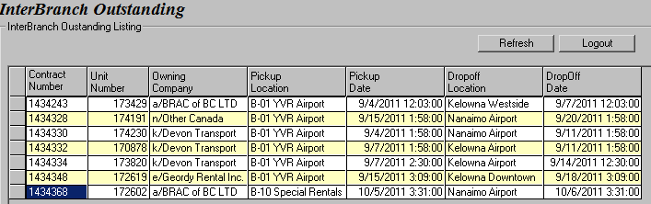

To close off the contract, you must double click on the contract you want to update. In our example, we want to check in contract number 1434368, so double anywhere on the line of the contract number. Once the user double clicks on the contract number, the module of Contract Check in will pop up for the user to confirm and process payment. All the Mandatory fields – Date in, Time in, Drop off Location, KM in, Vehicle Condition and Fuel Level will pre-fill with data from the checked in location. (please refer to screen below)

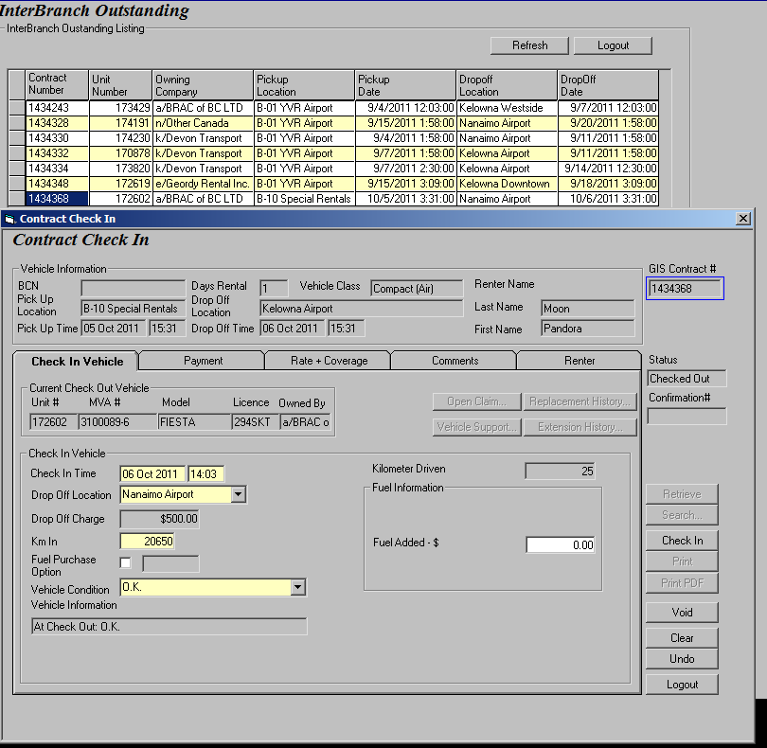
The user can confirm the data, collect payment and checked in the contract in the same manner as closing a local contract.

